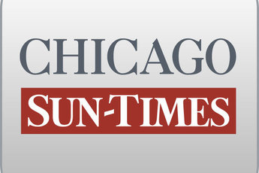
January 12, 2009 Monday
Final Edition

Gov denies stalling $8M for kids' doctors; Accused of demanding donation

By Chris Fusco and Dave McKinney
Springfield bureau chief
SPRINGFIELD-Gov. Blagojevich says he isn't intentionally holding up $8 million in funding for children's specialty doctors across the state, but he admits the money is being delayed because of "the complexities involved" in awarding it.

Responding to a story in Sunday's Chicago Sun-Times in which a state lawmaker was highly critical of the governor's handling of the matter, the governor's press office issued a statement saying the issue should be resolved by mid-February.

One of the charges the governor faces in his criminal complaint is that he allegedly stalled the funding for children's specialty doctors to try to squeeze a $50,000 contribution from Patrick Magoon, chief executive officer of Children's Memorial Hospital, which led efforts to get that funding.

Rep. Susana Mendoza (D-Chicago), who led efforts to raise Medicaid reimbursement rates the state puts toward specialty care for low-income children, called the governor's actions "repugnant" and criticized him for still not freeing up the cash.

Blagojevich's press office said the higher rates for pediatric hospitals were supposed to kick in Jan. 1, but that "increasing the reimbursement rate is a complicated procedure.

"Due to the complexities involved and the [Department of Healthcare and Family Services'] desire to make sure the increase is handled correctly, the reimbursement rate is expected to be in place by the middle of February."

Reacting to the statement, Mendoza said, "The way I see it, this should already have been done by Jan. 1. The governor had no intention of making that happen without that campaign contribution in exchange -- that is clear in my mind. There is no excuse for waiting until February to get this done."

