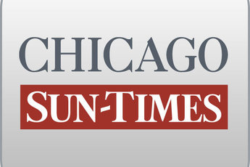
December 29, 2008 Monday
Final Edition

Gov's lawyer to offer report clearing Obama insiders

By Dave McKinney
Springfield bureau chief
SPRINGFIELD-
Gov. Blagojevich's lawyer today intends to submit President-elect Barack Obama's internal report to a House impeachment panel as evidence the governor wasn't trying to enrich himself while deciding whom to appoint to Illinois' vacant U.S. Senate seat.

Denied the ability to subpoena Obama's inner circle, defense attorney Ed Genson told the Chicago Sun-Times on Sunday that the report will buttress his arguments the governor has done nothing wrong and deserves to remain in office.

"Since I can't subpoena anyone, this is the next best thing," Genson said.

Last week, Obama's transition team released a report concluding that incoming White House chief of staff Rahm Emanuel had one or two phone calls with Blagojevich regarding the Senate appointment and another four calls with the governor's former chief of staff, John Harris, who has been charged along with the governor.

The Obama report noted that Emanuel was pushing Obama adviser Valerie Jarrett for the seat but concluded no wrongdoing on the part of Obama's aides or any indication that the governor was attempting to seek a Cabinet appointment or ambassadorship under Obama in exchange for appointing Jarrett or anyone else.

The chairwoman of the House Special Investigative Committee, Majority Leader Barbara Flynn Currie, said she expects Genson will be permitted to submit the Obama report as evidence in the impeachment inquiry.

Currie turned down a bid by Genson to subpoena Emanuel, Jarrett, U.S. Rep. Jesse Jackson Jr. and Chicago Tribune executive Nils Larsen after U.S. Attorney Patrick Fitzgerald objected, saying their testimony before the impeachment panel could "significantly compromise" the criminal probe against Blagojevich.

The Sun-Times identified Jackson as the unnamed "Senate Candidate 5" and Larsen as an unnamed Tribune "financial adviser" who were referred to in a 76-page criminal complaint Fitzgerald lodged against the governor Dec. 9.

Blagojevich was charged after secret government recordings allegedly showed he was trying to leverage his appointment for the open Senate seat in exchange for a federal post or high-paying jobs for himself and wife Patti.

Meanwhile Sunday, Lt. Gov. Pat Quinn predicted on CBS' "Face the Nation" that Blagojevich would be impeached by the House and convicted in the Senate before Abraham Lincoln's bicentennial celebration Feb. 12.

