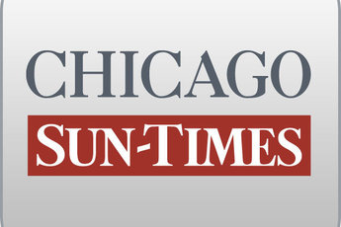
May 23, 1998, SATURDAY, Sports Final Edition

State Senate OKs pay raises, tougher ethics rules

By Dave McKinney
Springfield bureau chief
SPRINGFIELD-The Illinois Senate on Friday allowed state pay raises to go through and passed legislation designed to clamp down on HMOs and toughen government ethics laws.

By Friday evening, lawmakers still had not passed a $ 37 billion-plus state budget that includes a series of tax cuts, or a teacher pension sweetener. Approval of both was expected late Friday before the General Assembly adjourned its spring session.

Capping the busy day was the surprise approval of pay raises, which will boost salaries of constitutional officers and other lawmakers by 2 percent and judges by 3 percent next year. That increase comes on top of a 2.9 percent cost-of-living adjustment that automatically takes effect in July.

"We're entitled to this. It's not outlandish. It's nothing that's exorbitant," said Sen. Denny Jacobs (D-East Moline), who helped vote down a resolution disapproving the pay raises.

A day after the House moved to block the raises, the initiative fell five votes shy in the Senate. State law requires both legislative chambers to disapprove the raises to keep them from taking effect.

Meanwhile, the Senate overwhelmingly approved a campaign finance package that would prohibit politicians from using their campaign funds like personal bank accounts.

The plan, which passed 52-4, also would prohibit political fund-raising on state property and ban all state employees and officials from accepting gifts from state contractors, lobbyists or other interests.

"This sets the standard for us, and communicates to a public that is increasingly cynical about Springfield and the General Assembly that we in fact are willing to do the right thing," said Sen. Barack Obama (D-Chicago), a co-sponsor of the proposal.

The House was expected to vote on the package Friday night.

But the Senate initiative involving HMOs was expected to stall in the House. The Senate plan, which was opposed by the state's HMO industry, would have prevented HMOs from restricting doctors' conversations with patients about treatment options.

It also would have prevented HMOs from requiring prior authorization before emergency room visits.

