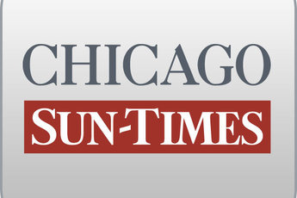
January 14, 2011 Friday

Blago rips tax hike: 'I hate the fact I was right about this'

By Dave McKinney
Springfield bureau chief
SPRINGFIELD - Besides his taped, profanity-laced conversations and impeachment, Rod Blagojevich is remembered for keeping a lid on the state income tax and giving senior citizens free rides on public transportation while he was governor.

On Thursday, Gov. Quinn signed off on raising the state income tax, and Blagojevich's other signature accomplishment also may soon be going the way of his governorship if Quinn OKs legislation to roll back the senior-rides program.
Guess who is none too happy.

"I hate the fact I was right about this," Blagojevich told the Chicago Sun-Times Thursday in his first public comments on this week's votes in the General Assembly to raise the state income tax and do away with free rides for all seniors.

"It's a mindset that Quinn, the insiders in Springfield and these lawmakers have. And it's this: The question for them isn't what we can do for the people, but what can the people do for us," Blagojevich said.

"The way they did it is very cynical by having the lame-duck Legislature, where some members actually got beat, raise taxes 66 percent and take public transportation away from your grandmother. This illustrates exactly what I fought for six years. ... If they thought this was the right thing to do, why didn't they do this before the election?" Blagojevich said.

"They said to the people, late at night when no one was watching, we'll ram this thing through where the old Legislature can vote to stick it to the people, and they won't have to answer to you," he continued. "It's just a bad thing to do to people."

Blagojevich also lambasted House Speaker Michael Madigan (D-Chicago) and Senate President John Cullerton (D-Chicago) - along with Quinn the main architects of the tax hike - for not also curtailing double-dipping lawmakers, preventing legislators from employing their relatives on the state payroll or passing ethics laws to regulate the property-tax appeals work that Madigan and
Cullerton's law firms do when "they make the rules that govern how you assess real estate taxes."

Told of Blagojevich's assertions, Madigan spokesman Steve Brown ridiculed the ousted governor, who faces an April retrial after a federal jury deadlocked on 23 of 24 corruption counts against him.

"The man is a sociopathic fraud. Part of the reason the state is in the dilemma it is, is because of his bungling as governor and his unquenchable thirst to create spending programs so people would idolize him, which is all part of his condition," Brown said.

Brown said he was surprised Blagojevich did not express himself before the votes, "but that would've meant he would have had to drive his own car to Springfield, not the taxpayers' car."

