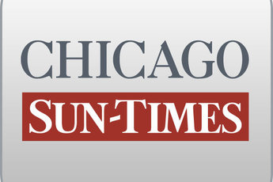
October 28, 1999, THURSDAY, Late Sports Final Edition

Cigars, rum popular souvenirs of governor's entourage

By Dave McKinney
Springfield bureau chief
HAVANA-Gov. Ryan's flight home from Cuba on Wednesday was weighted down with highly sought-after cigars, rum and other souvenirs scooped up by members of his humanitarian mission.

Many of the roughly 90 passengers -- ranging from politicians to business leaders to members of the news media -- filled carry-on bags with the treasured commodities, which cannot be sold in the United States.

House Speaker Michael Madigan, who does not smoke, brought back two boxes of cigars that he intends to pass out to friends and political allies, including the man who occupies the fifth floor of City Hall.

"Before I left I had requests to bring back cigars," the Southwest Side Democrat said. "I'll take at least one in to Mayor Daley. I know he likes to chew cigars in his office."

Federal law, enforced by the U.S. Customs Service, allows visitors to Cuba to return to the United States with no more than $ 100 in Cuban goods, excluding artwork.

Prices for cigars range from as little as $ 25 a box to as much as $ 380 for a box of premium Cohibas. Rum, meanwhile, costs between $ 3 and $ 14 per bottle, depending on its age.

Ryan and first lady Lura Lynn Ryan brought back gifts they had received during the trip, including perfume, a poster of Ernest Hemingway, a drawing of Cuban independence leader Jose Marti and one cigar for the governor, Ryan spokesman Dave Urbanek said.

Rep. Dan Rutherford (R-Pontiac) brought back a box of cigars and a bottle of rum that he said wound up well below $ 100.

"For me, it's alluring because it's something you can't get in the states," Rutherford said.

Breaking into laughter, Rutherford added, "I can tell the difference between a Cohiba and a Swisher Sweet (cigar)."

The Downstate lawmaker said he and other members of the delegation did not have much time to load up on souvenirs.

"I think most people are playing this pretty straight," he said.

